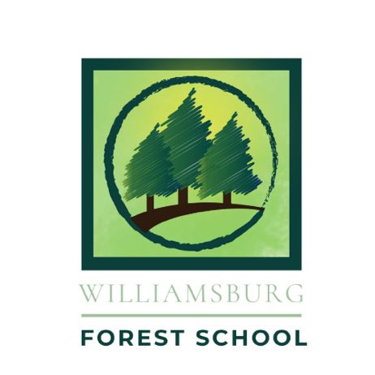
APPLICATION FOR ENROLLMENT
2026-2027 school year
Elementary Program

PART I: STUDENT INFORMATION
Child’s name: ______________________________________

Date of birth: ________________ Grade entering in Fall 2026: ___________

Gender: ______________
Please tell us a bit about your child. What are your child’s likes and dislikes?

Please list your child’s previous educational experience (e.g., homeschool, public school, preschool, etc.), including the school name(s) and dates attended.

What did your child like most and least about those educational experiences and why?

Did your child experience any difficulties in either past or current educational or social settings? Please explain so that we can better understand how to meet his/her needs.

Does your child have any diagnosed special needs (e.g., motor, language/speech, psychological, emotional, and/or social)? If yes, please explain. Upon acceptance, we will ask you to provide any relevant documentation separately so that we can know how best to support your child.

Does your child have any known allergies (if so, please specify)?

Does your child have any ongoing health issues? Any medications currently being taken or that need to be available (e.g. an inhaler for asthma or Epi-pen for allergies)?

PART II: PARENT/GUARDIAN INFORMATION

Parent/Guardian 1
Name: ___________________________________________________

Email address:___________________________

Cell phone: ______________ Work phone: _______________________

Parent/Guardian 2
Name: ___________________________________________________

Email address:_________________________

Cell phone: ____________ Work phone: _____________________

Part III: Family Information

Please be assured that there is no “right” answer to the questions below. We simply seek to know your family better!

Why do you think Williamsburg Forest School might be a good fit for you and your child?

Please describe the learning environment you seek for your child.

What concerns do you have about non-traditional or progressive education?

Part IV: Student Evaluation Form
In order for your child’s application for enrollment to be considered complete, we must receive a confidential student recommendation form from your child’s most recent teacher, or in the event your child was most recently homeschooled, a non-family member adult who knows your child and can comment on your child’s personality, socioemotional maturity, and learning abilities. Please indicate below to whom we should send the confidential form.

Name and Title: _______________________________
Email: _______________________________________
Please also inform the person you have identified above that this request is pending and provide him/her your permission to answer us confidentially.

Part V: Enrollment Policy
- When a child is accepted to the school, parents will receive an enrollment contract.
- After receipt of a signed contract and non-refundable deposit of $500, the school will reserve a child’s space in the program and send enrollments forms to be completed before the start of school.
- The deposit is applied toward the annual tuition obligation.
- An enrolled child will not need to submit another application for a subsequent year.

Part VI: Tuition and Affordability
Tuition is set at $10,000 for the school year. ($1,000 per month over 10 months or in larger increments as preferred). The $500 deposit will be deducted from the first payment. Should a family choose to pay in one or two larger payments, the deposit will be deducted from the first payment.

Affordability
At the Williamsburg Forest School, we believe that cost should not prevent a child from experiencing an exceptional education. Please talk to us about the possibilities of a tuition assistance plan.
​
Virginia 529
Families with 529 college savings plans are now able to use those investments to pay up to $10,000 per year in tuition expenses for their children’s K-12 education. Families are encouraged to visit Virginia529.com and to consult with a financial advisor to evaluate the potential benefits available under this new law.

-------------------------------

Please return this form with deposit to Jocelyn Swanson, Co-Director, Williamsburg Forest School:
Mail: P.O. Box 54, Norge, Va. 23127
Email: Fieldsprouts@gmail.com (We accept Venmo - @jocelyn-Swanson-1 and PayPal – write2say@msn.com. NOTE: If using PayPal, please check “family and friends” to avoid a service charge.)

